**Change Folder permission in Windows:**

Changing folder permissions in Windows is a straightforward process, but it’s essential to have the proper administrative privileges to make these changes. Below is a step-by-step guide on how to change folder permissions in Windows:

Step 1: First create a user with name **‘IT’.**

Go to ‘Computer management’

Local Users & Groups

Users

New user

Put a user name ‘IT’ & Password and then click on ‘create’.

Now a user called **‘IT’** is created.

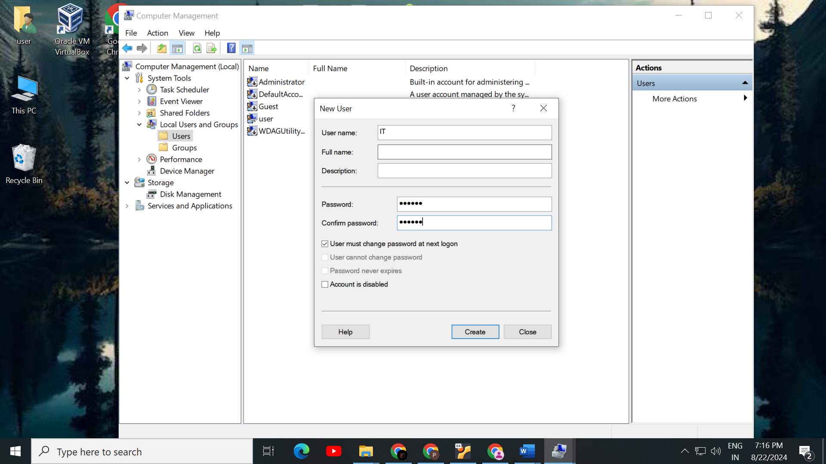

**Step 2: Access Folder Properties**

**Locate the Folder:**

* Navigate to the folder you want to change permissions for using File Explorer

Here I want to change the permission of a folder name ‘Pratik’, located in local disk D:

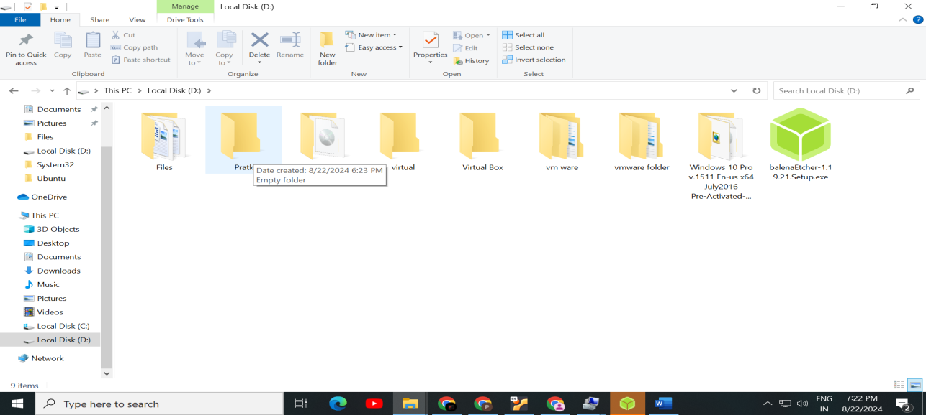

### Step 3: Modify Permissions

Now right click on the folder ‘Pratik’ and select ‘properties’ go to ‘Security’ tab.

Now I have to add the new user ‘IT’ in the list here. To add new user ‘IT’ click on Edit -> Add

Type the name of the user ‘IT’ in the object name box. and select ‘check names’ and select ‘ok’.

Now ‘IT’ user is displaying in the list

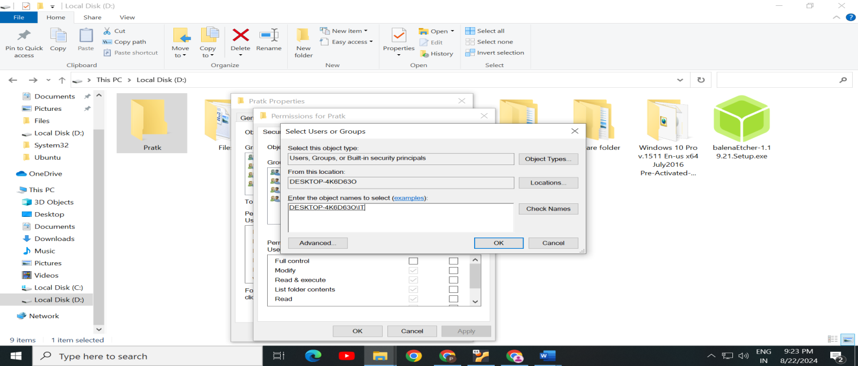

**Step 4:** **Edit Permissions**

Now to change the Folder permission, select ‘IT’ user and click on ‘Edit’ and change ‘Read’ option into Allow and ‘Write’ option into Deny.

‘Pratik’ folder permission has been changed for ‘IT’ user

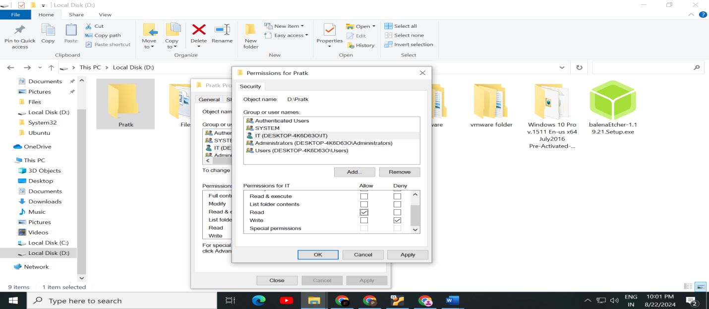

**Step 5: Test Access**

* Optionally, log in as the user or access the folder with the permissions you set to ensure everything works as expected.

Here log in into ‘IT’ user. And navigate to ‘Pratik’ folder and you will encounter an error message when you will try to Delete ‘Pratik’ because your Write permission is denied from Administrator user.

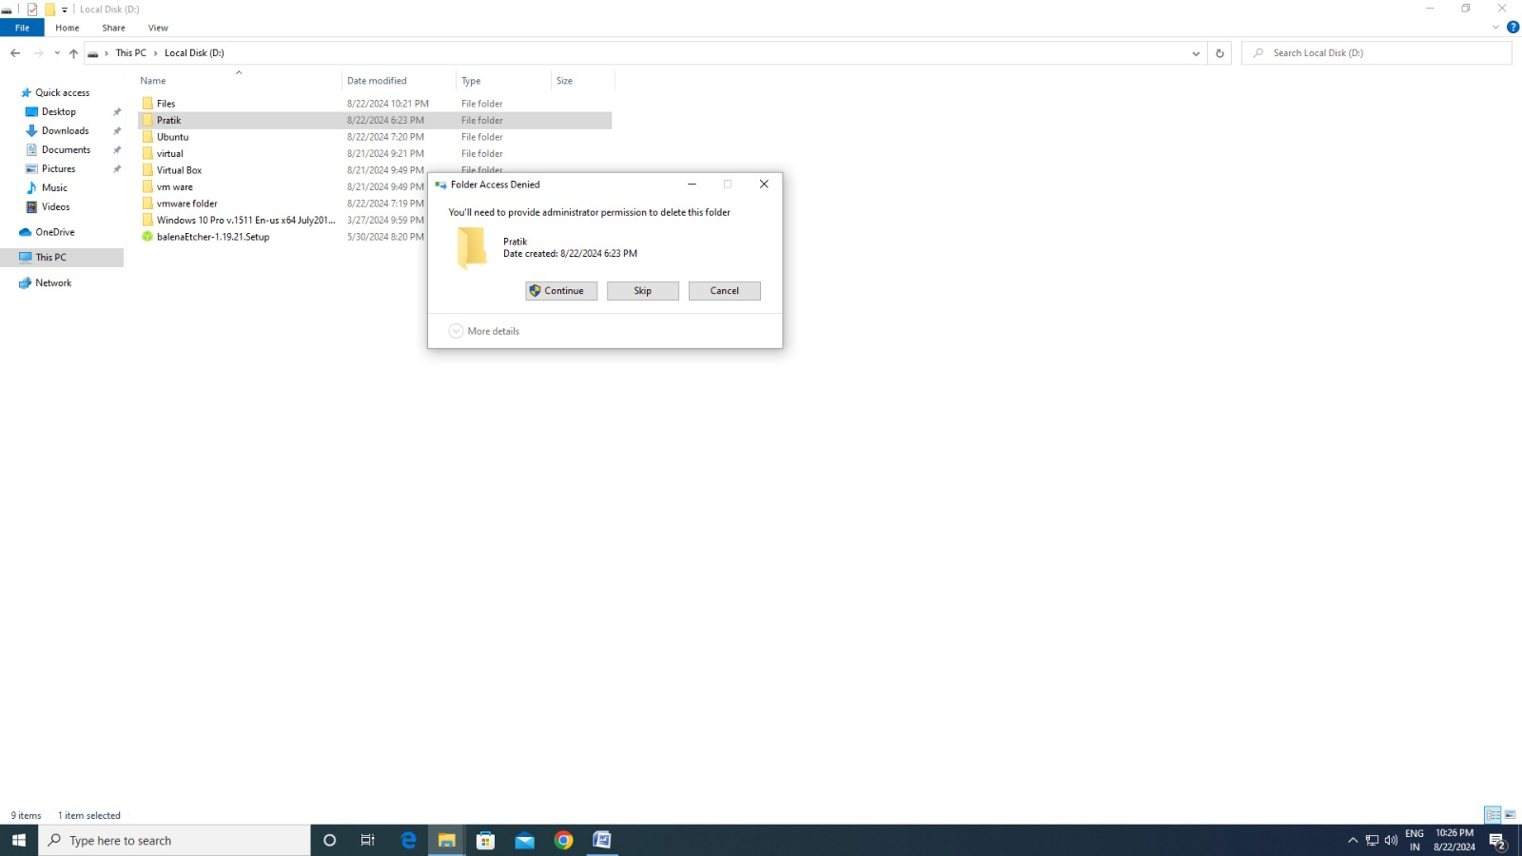

Important Considerations:

Administrative Privileges: You need administrative privileges to change folder permissions.

Propagation of Permissions: Changes to a folder’s permissions can be propagated to its subfolders and files, depending on the settings.

Impact on Users: Be cautious when removing permissions, as it might prevent users from accessing important files or folders.

By following these steps, you can easily manage and change folder permissions in Windows, ensuring that only authorized users have the appropriate access.